|  |  |  |
| --- | --- | --- |
| **Please list all names of group members:**  (Surname, first name)  1. Remani, Shaan Ali  2. Chen, Gael  3. Sashinkumar, Fabrice | 4.  5.    **5**  **GROUP NUMBER:** | |
| **MSc in: Quants Cluster** | | |
| **Module Code: SMM265** | | |
| **Module Title: Asset Pricing** | | |
| **Lecturer:** Dirk Nitzsche | | **Submission Date: 25 Nov 2024** |
| **Declaration:**  By submitting this work, we declare that this work is entirely our own except those parts duly identified and referenced in my submission. It complies with any specified word limits and the requirements and regulations detailed in the coursework instructions and any other relevant programme and module documentation. In submitting this work we acknowledge that we have read and understood the regulations and code regarding academic misconduct, including that relating to plagiarism, as specified in the Programme Handbook. We also acknowledge that this work will be subject to a variety of checks for academic misconduct.  We acknowledge that work submitted late without a granted extension will be subject to penalties, as outlined in the Programme Handbook. Penalties will be applied for a maximum of five days lateness, after which a mark of zero will be awarded. | | |
| **Marker’s Comments (if not being marked on-line):** | | |

**Deduction for Late Submission: Final Mark:**

***For Students:***

**Once marked please refer to Moodle for your final coursework grade, including your Peer Assessment grade.**

**Optimal Investing:**

**Balancing Risk and Reward Over a Decade**

**Prepared By: Shaan Ali Remani, Gael Chen,**

**and Fabrice Sashinkumar**

**Date: 25th November 2024**

Contents:

1. Introduction 5

2. Forecasting Model: When Should You Invest? 5

3. Stock Selection 5

4. Efficient Frontier and Risk-Return Profiles 6

5. Considerations for Replicating Mean-Variance Optimisation 7

6. Terminal Wealth Calculation and Analysis 7

7. Recommendation 7

Appendix 1: EGARCH Model 8

Appendix 2: Stock Correlation Matrix 10

Appendix 3: Efficient Frontiers (In Depth) 11

Appendix 4: Investment Period – Statistical Insight 16

Figures:

Figure 1: Portfolio performance during Dotcom Bubble 'Burst' and Financial Crisis 5

Figure 2: Efficient Frontiers (Semi-Annual), showing Minimum Variance Portfolios, Market Optimum Portfolios, and Capital Allocation Lines 6

Figure 3: Forecasting Model-Guided Portfolio’s Relative Performance 7

Figure 4: EGARCH Model Forecasts of FTSE All Share Log Returns vs. Actual FTSE All Share Log Returns 8

Figure 5: Model Performance Statistics 8

Figure 6: Periods of high volatility follow periods of high volatility (e.g. 2008 Financial Crash) 9

Figure 7: Autocorrelation of Squared Residuals (note Lag 1, 3, and 8). 9

Tables:

Table 1: High-level overview of factors in EGARCH model 5

Table 2: Investment Decisions forecast a strong market with investment in 80% of periods. 5

Table 3: Terminal Wealth over the 10-Year Investment Period and CAGR for Portfolio Strategies 7

Table 4: Summary Statistics for Portfolios during Investment Period. 16

# **1. Introduction**

This report analyses the performance of seven portfolios generated through *mean-variance optimisation* (**Section 4**) over the 10-year period from October 31st 2014 to October 31st 2024, “*Investment Period*”, using historical data between 31st December 1995 and 30th September 2014, *“Pre-Investment Period”*. Terminal wealth calculations show our *“Forecasting Model-Guided Portfolio”* delivers the best returns (3.72% CAGR), outperforming the FTSE All Share index, “*the* *market*” (+1.79% CAGR). We recommend this portfolio for investors wishing to build long-term wealth, avoid market uncertainty, and maximise risk-adjusted returns.

# **2. Forecasting Model: When Should You Invest?**

An EGARCH model is used to forecast market volatility, capturing 51% of historic data (**Appendix 1**).



Table : High-level overview of factors in EGARCH model

Decision Framework:

Investment decisions are made on a semi-annual basis. If the average forecasted market return over the next period is greater than the current UK 1-month government bond yield, we invest in the market for the following 6-month period. Otherwise, we invest in government bonds[1].



Table : Investment Decisions forecast a strong market with investment in 80% of periods.

# **3. Stock Selection**

Our portfolio, tailored for risk-averse investors, consists of 5 UK Companies: AstraZeneca, British American Tobacco, Bunzl, National Grid, and Vodafone. These stocks optimise the risk-return trade-off with high Sharpe Ratios, and are diversified across industries to have low correlations, and minimise company-specific risk (**Appendix 2**). Owing to this, the selected stocks have demonstrated robust performance during crises (**Figure 1**).

Figure : Portfolio performance during Dotcom Bubble 'Burst' and Financial Crisis

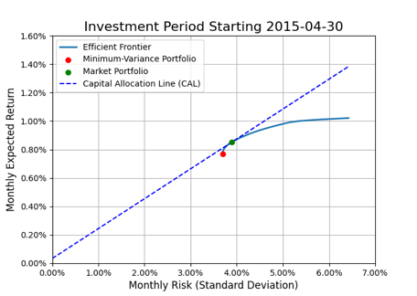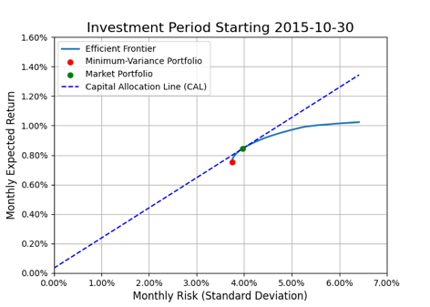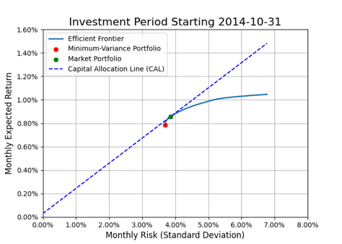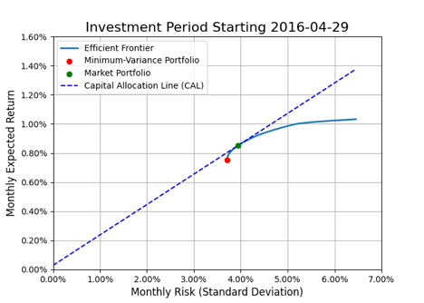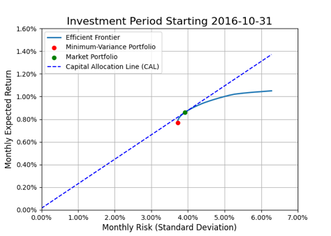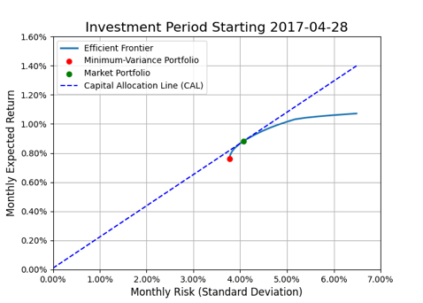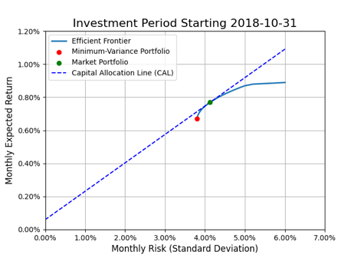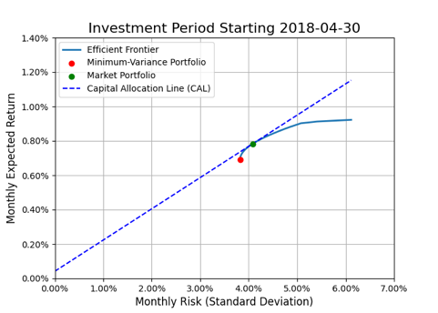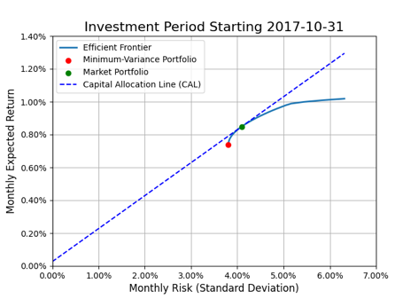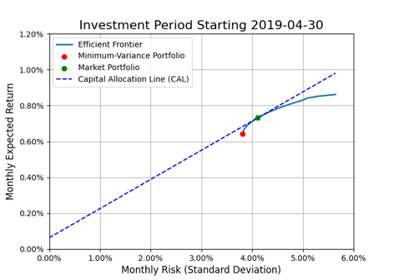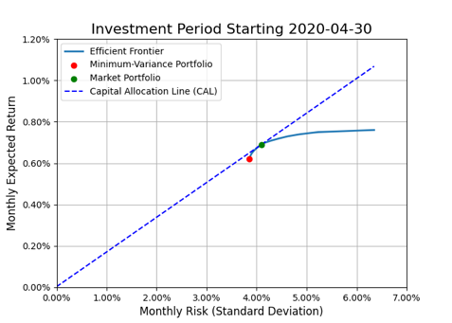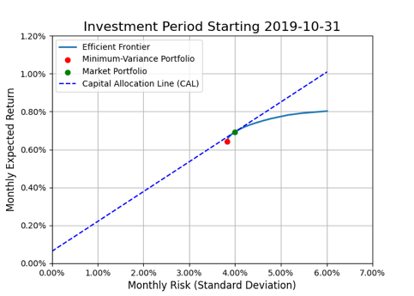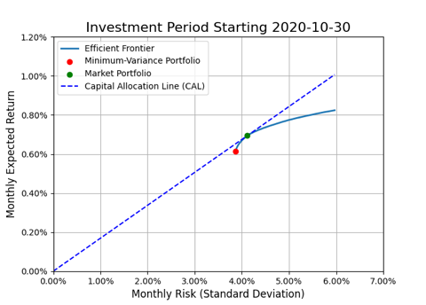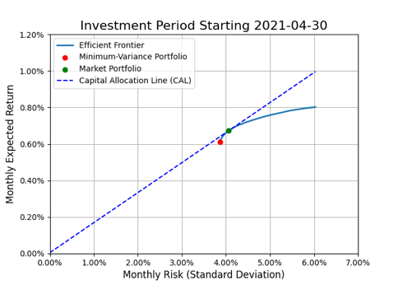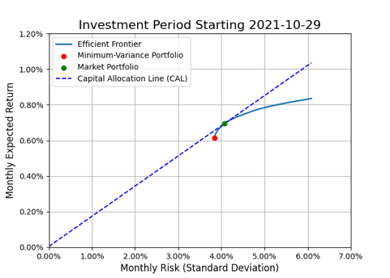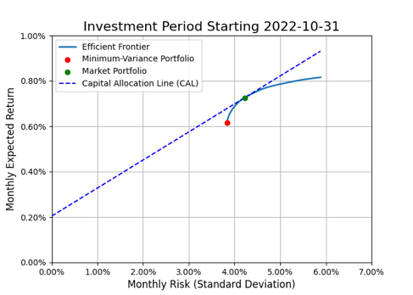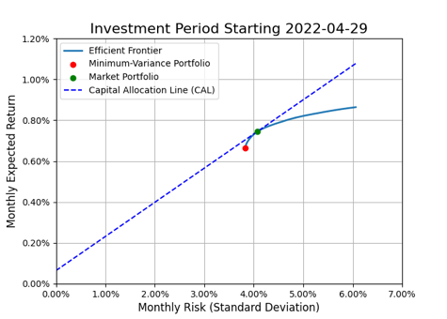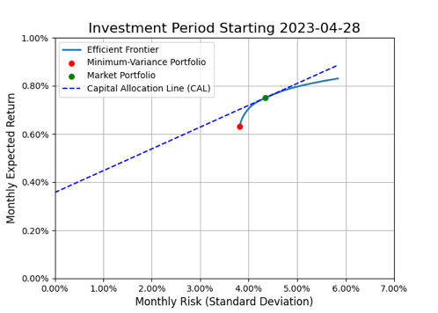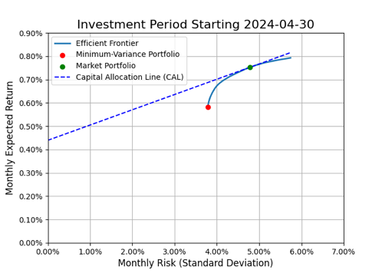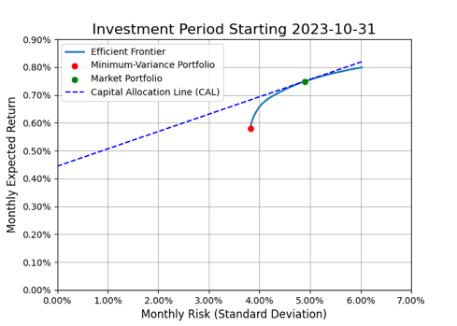

Clicking the efficient frontiers for each period directs to the risk-return profiles (**Appendix 3**). *Minimum-Variance Portfolio* offers stable growth with the lowest risk over the investment period – ideal for risk-averse investors. *Market Portfolio* provides moderate risk exposure, balancing risk and return. Points on CAL represent specific risk-return profiles, which can be tailored to clients’ risk tolerance by combining investments in government bonds and the market portfolio.

# 4. Efficient Frontier and Risk-Return Profiles

Figure 2: Efficient Frontiers (Semi-Annual), showing Minimum Variance Portfolios, Market Optimum Portfolios, and Capital Allocation Lines

# 5. Considerations for Replicating Mean-Variance Optimisation

Mean-variance optimisation is highly sensitive to its inputs, particularly calculations of expected returns and risk. Even with a diversified portfolio, a high expected return for a single asset can cause the model to heavily weight that asset. If this input is inaccurate, the portfolio can become overly concentrated and may result in significant losses. Companies are also assumed to be fairly valued (not underpriced or overpriced) and so optimisation relies solely on expected returns and risk. It does not account for potential reversion to true value (for overpricing), which may negatively impact performance.

This report uses historical mean returns and standard deviations as proxies to demonstrate the advantages of our forecasting-model-guided portfolio. The proprietary methodology used to evaluate company fundamentals is not disclosed in this analysis.

# **6. Terminal Wealth Calculation and Analysis**



Table : Terminal Wealth over the 10-Year Investment Period and CAGR for Portfolio Strategies

Rebalancing portfolio weights every 6 months has mixed results; improving *Market Portfolio’s* performance (+0.25% CAGR) but reducing *Minimum Variance Portfolio’s* performance (–0.43% CAGR). We suggest investors carefully consider rebalancing strategies, as outcomes depend heavily on the specific portfolio.

*Minimum Variance Portfolio (No Rebalancing)* beats *Market Portfolio (No Rebalancing)* (+1.01% CAGR), due to its lower exposure to the market downturn caused by COVID-19 pandemic **(Figure 3 Left).**

The best-performing strategy is the *Forecasting Model-Guided Portfolio* which enters positions in *Market Portfolio* based on forecasts in **Section 2** without rebalancing. Its lack of negative returns **(Figure 3 Right)** reflects consistent risk-adjusted growth, demonstrating the benefits of mean-variance optimisation combined with forecasting. The lower performances of the market and government bonds emphasise the importance of diversification for investors.

|  |  |
| --- | --- |
|  |  |

Figure : Forecasting Model-Guided Portfolio’s Relative Performance

# **7. Recommendation**

We strongly recommend *Forecasting Model-Guided Portfolio* for investors as it delivers greatest returns by adapting risk exposure to changing economic conditions. For steady wealth accumulation with lower risk, the Minimum Variance Portfolio remains a compelling choice.

Appendix 1: EGARCH Model

Figure : EGARCH Model Forecasts of FTSE All Share Log Returns vs. Actual FTSE All Share Log Returns

Figure : Model Performance Statistics

Stationarity Check (ADF Test):

* ADF Statistic: –18.0573
* p-value: 2.63x10–30

Conclusion: Statistical properties of FTSE All Share index returns are consistent over time (null hypothesis of non-stationarity is rejected).

ARCH Effects Test:

• Statistic: 28.886

• p-value: 0.0013

Conclusion: *Significant ARCH effects* are present, indicating that there may be periods of high and low market uncertainty (volatility clustering). The time-series plot of scaled returns (**Figure 4**) illustrates periods of high volatility, which often coincide with economic crises, and low-volatility, suggesting market stability. The observed clustering indicates that a highly uncertain period is likely followed by another. The p-value is below 0.05, indicating significant ARCH effects; the patterns of market uncertainty are not random, but follow systematic patterns.

Figure : Periods of high volatility follow periods of high volatility (e.g. 2008 Financial Crash)

Autocorrelation of Squared Returns (ACF):

The autocorrelation function of squared returns supports the presence of volatility clustering. The ACF plot of squared returns (**Figure 5**) shows significant spikes at multiple lags, indicating that if the market experiences high volatility, it is likely to continue being volatile in the short term. This is often modelled using GARCH (Generalised Autoregressive Conditional Heteroskedasticity).

Figure : Autocorrelation of Squared Residuals (note Lag 1, 3, and 8).

Appendix 2: Stock Correlation Matrix

Appendix 3: Efficient Frontiers (In Depth)

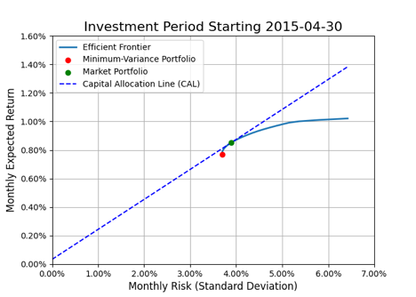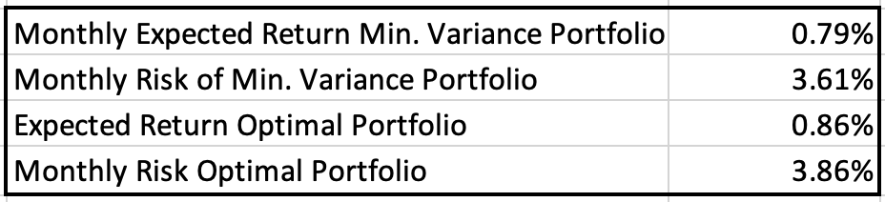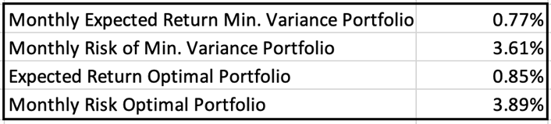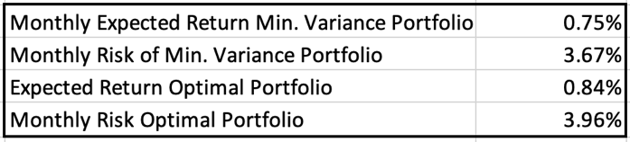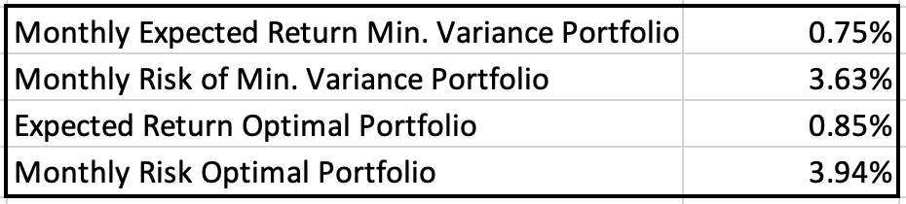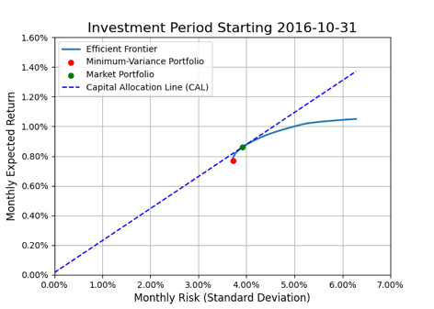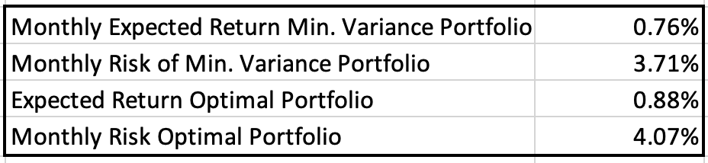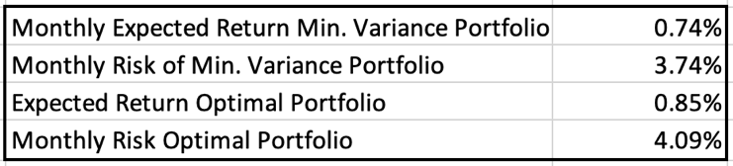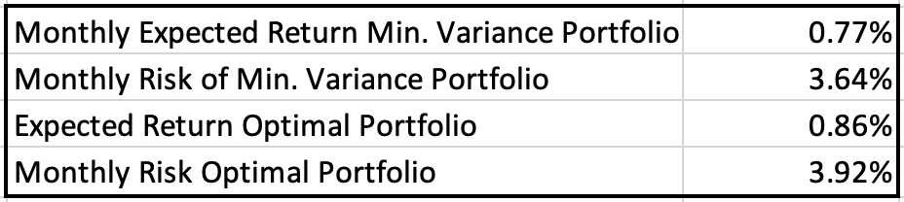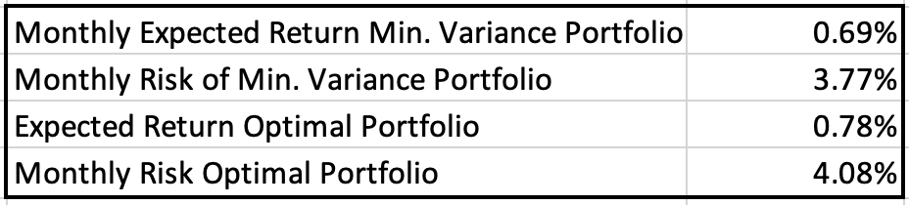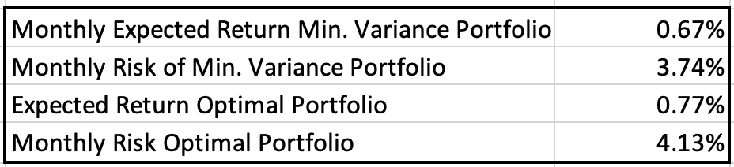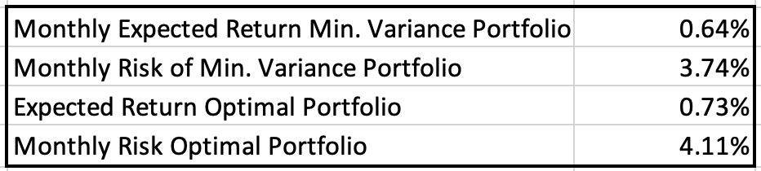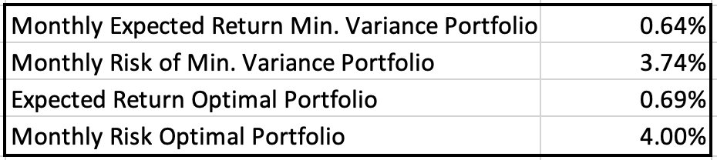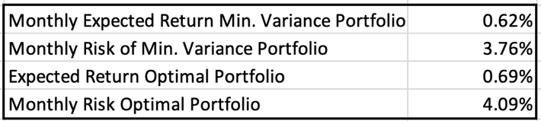

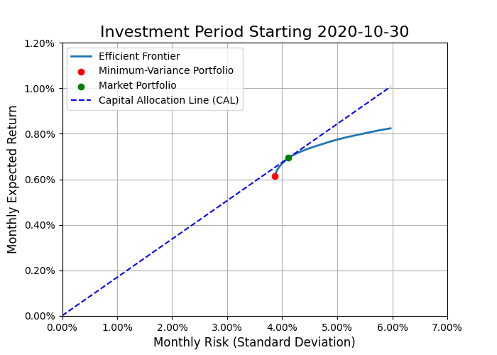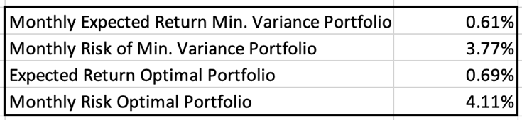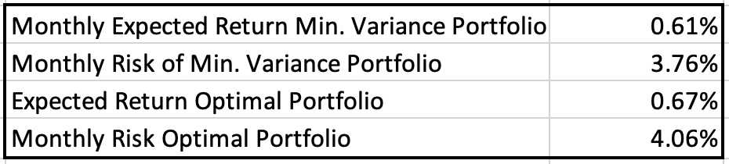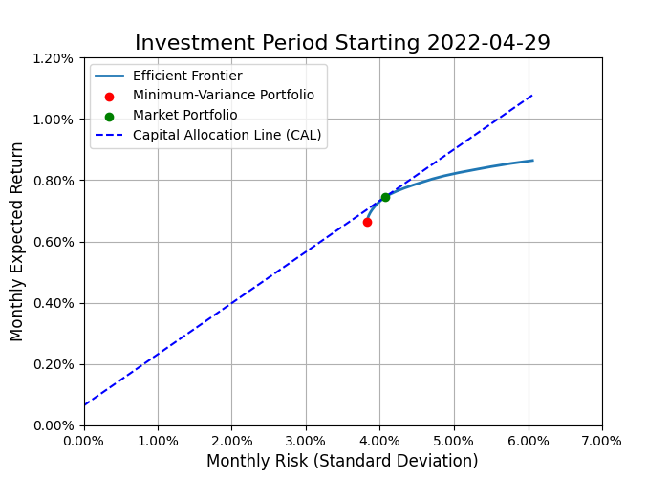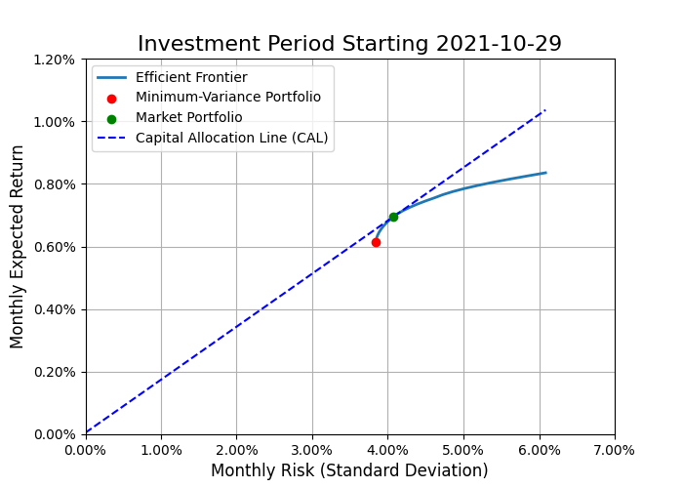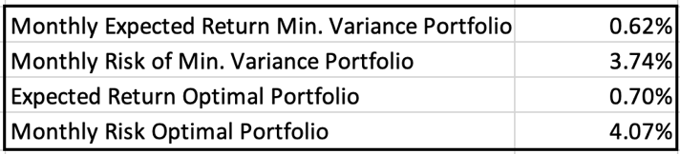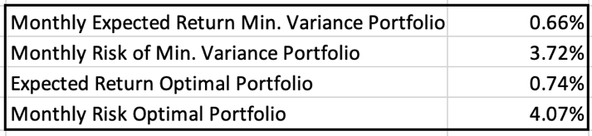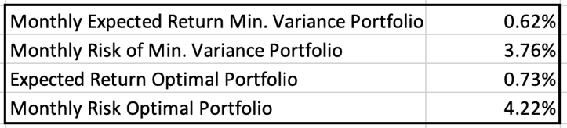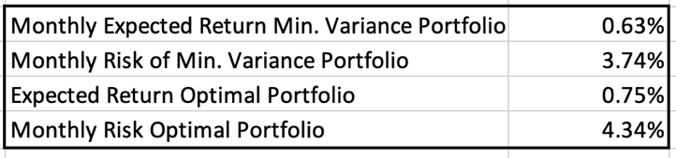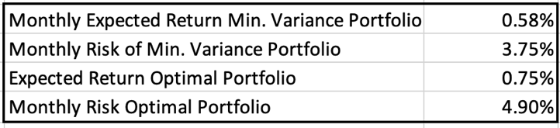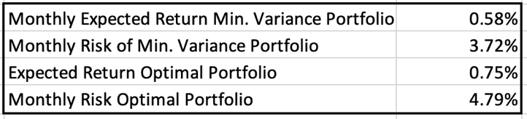

# Appendix 4: Investment Period – Statistical Insight

Table : Summary Statistics for Portfolios during Investment Period.

1. UK 1-Month Government Bonds are considered ‘risk-free’ investments since the UK government has an almost-0 likelihood of defaulting on short-term debt obligations.